Allocation Request Template Form Instructions
-This Form is to be Submitted to the SGA Email (sga@stevenson.edu) by March 31st, 2024 at 11:59PM. For everyday this form is late, a $25.00 fine will be applied to Next Years Budget.
-A club must be considered Active/Provisional in order to receive Allocation for the next year. If you have any questions regarding your club’s standing feel free to contact me!
-This Form is a way to help your club plan out events it is interested in holding next year and allows your club to request money from SGA to plan these events.
-The Allocation that your club requests will be for the Entire 2024-2025 Academic School Year. The club should consider events for Both the Fall and Spring Semester when determining your Allocation Request
-Please keep in mind that the SGA has to allocate money to every club that Requests money, this means that we often cannot given clubs unlimited funds. Please keep a modest budget in mind when requesting your allocation.
-Please feel free to reach out! I am happy to meet and discuss any questions or concerns. I can assist with filling out the form, assisting in creating a budget for next year, or answer any questions!

Template Breakdown: Please Note the Examples of how to Correctly Fill out the Allocation Form
- Purple Boxes – Contact/General Club Information
  - Fill out all the information about Current Club Leader Information
  - Fill out all information about Next Year’s Club Leaders Information
    - If your club has not appointed/voted, please leave blank for the time being and then Email Tomi with the updated information following appointment
  - Fill out information about Current/Requested Budget
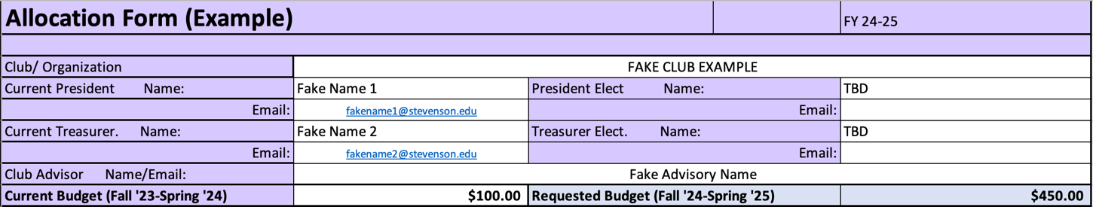
- Green Boxes – Fundraising Attempts
  - Left Side – Fundraising Attempting This Year (Fall 2023-Spring 2024)
    - Fill out Name of fundraising event and how much the event made
    - *If planning events after 3/31/24 – Estimate how much money event will make
  - Right Side – Fundraising Attempts for the Upcoming Year (Fall 2024-Spring 2025)
    - Fill out Name of Anticipated Fundraising Event and an estimate of how much money event will make
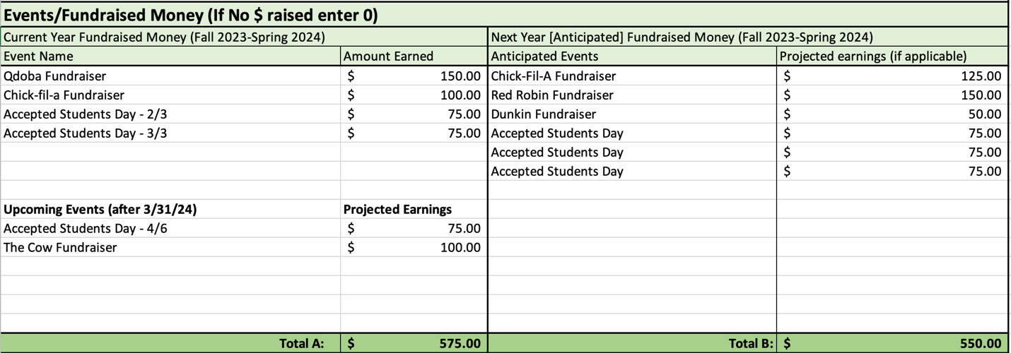

- Yellow Boxes – Projected Expenses for the Upcoming Year (Fall 2024-Spring 2025)
  - Fill out Anticipated Events that club will be spending money on, anticipated supplies, and the Total Anticipated Cost of Event
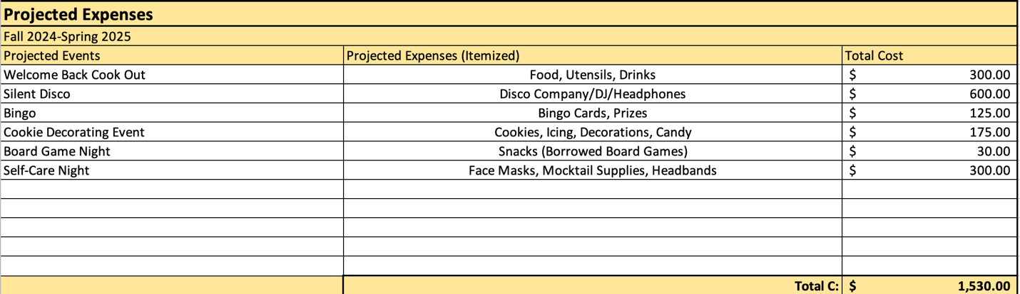
- Orange Boxes – Projected Budget Needs
  - This automatically calculates how much Money your club will need for the Upcoming Academic School Year based on the Answers Provided in the above sections
  - This is a tool to help your club with estimating budgetary needs - It is not your Final Request – you are able to request more or less
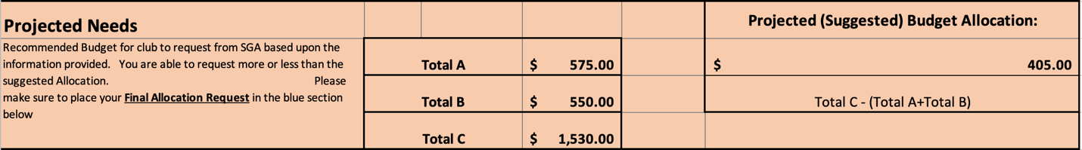
- Blue Box – Final Budget Allocation Request for the Upcoming Academic Year (F’24-S’25)
  - Fill in the Final Amount that your Club is Requesting
  - There are Two Places to Fill in this Final Request (Boxes H9 and G51)
  - *Keep in mind that the amount your request is not guaranteed for the Upcoming Year

